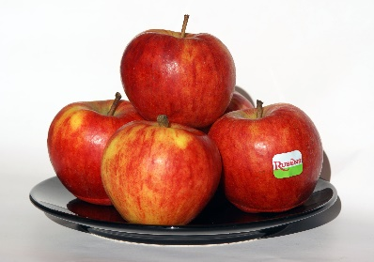
Unit Rates

AECKERSBERGMART

AeckersbergMart competes with three other markets in the neighbourhood. Mr. Aeckersberg wants his prices to be the lowest. To make this happen, he figures out which of his competitors has the lowest unit rate (or unit price) for an item. Then he rounds that price to the nearest cent and makes his price 2 cents less per unit.

Find the price of each purchase in AeckersbergMart.

AeckersbergMart Competitors
Item | GoGrocery | FunFruits | SuperMart
Corn | $0.30 each | 4 for $1.00 | 3 for $0.87
Pears | 2kg for $2.67 | 4kg for $4.99 | 3kg for $3.50
Bananas | 4kg for $4.85 | 3kg for $3.75 | 2kg for $2.40
Apples | 3 for $1.09 | 6 for $2.09 | 3 for $1.00
Cantaloupe | 3 for $4.59 | 4 for $6.40 | 2 for $3.09
Grapes | 1kg for $3.49 | 1kg for $3.44 | 2kg for $5.19

AeckersbergMart Prices
Items | AeckersbergMart's Low, Low Price
Corn | 6 for
Pears | 1kg for
Bananas | 1 kg for
Apples | 6 for
Cantaloupe | 5 for
Grapes | 2kg for

