Ancient Egypt Mapping Activity
Label the following:
*Shade the Nile River blue
*Shade the Nile River Delta area green
*Upper Egypt
*Lower Egypt
*Giza – label and draw a pyramid icon
*Sakkara – label and draw a pyramid icon
*Heliopolis – label and draw an icon
*Hermopolis – label and draw an icon
*Al Kharga Oasis – label and draw an icon
*Valley of the Queens and Kings – label and draw an icon
*Karnak – label and draw an icon
*El Armana – label and draw an icon
*Temple of Abu Simbel – label and draw an icon
Label the following:
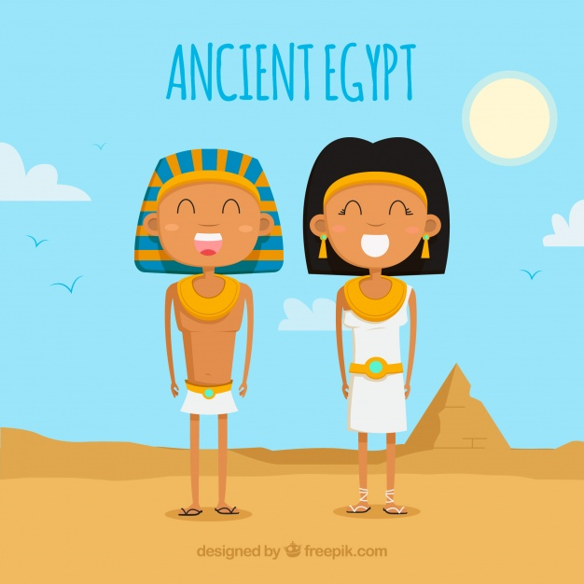
*Alexandria
*Cairo
*Memphis
*Luxor
*Abydos
*Aswan
*Edfu
*Sinai Desert
*Red Sea
*Mediterranean Sea

