Chemistry Notes

Name:_______________________ Section: _______

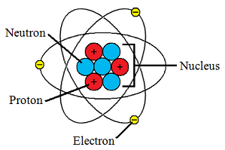

- Matter is anything that has weight and takes up space.

- The atom is the smallest whole part of matter.

- Most of the atom's weight is found in the nucleus.

- Proton: Part that has a POSITIVE charge. Found in the nucleus.

- Neutron: Has no charge (neutral). Also located in the nucleus.

- Electron: Has a NEGATIVE charge. Moves around the nucleus

- Nucleus: Center of the atom that contains the Proton and Neutron
- Atoms want to be stable. In order to be stable they have to either give away or take away electrons in their outermost layer in order to bond with other atoms.

- The electrons on the outer layer have a special name. They are called 'valence electrons', and the process in which these electrons are shared is called a chemical reaction.

- When these electrons are shared, new compounds are formed with different chemical and physical properties.

