French Travel Project Name:_________________________ Section: ____ - ____
You are going to research and plan a trip from Kelowna to a city of your choice in France…..and back!
Your task- Create five (6-10) colorful and interesting Google Slides for this project.
Slide 1: Title page: include your first and last name/section and your French city name and a picture related to your city of choice.
Slide 2: Flights – Use the website: expedia.ca (Click on the 'Flights' link)
On this slide include:
- The name of the airline company
- Your travel dates (your trip should be 7 days long)
- Cost of your flight (there and back)
- Departure and Arrival times
- A picture of your airline
Slide 3: Accommodation: Use the same website: expedia.ca (Click on the 'Stays' link)
On this slide include details for your 7 night stay:
- The name of the hotel
- The dates of your reservation
- The cost per night to stay there (in Canadian dollars$)
- The total cost of your hotel stay (total cost for 7 night stay)
- A picture of your hotel
Slide 4-5: Be a tourist in your French city:
- Highlight two (2) interesting/famous tourist spots in your city.
- Provide the name of the interesting/famous tourist spot
- Write a short description of each (what is it, history, why is it famous, etc.)
- Include a picture(s) of each
Slide 6: Make a Dinner Menu
- Create a sample dinner menu that people from your French city would eat. Your menu should include an appetizer, salad, main meal and dessert. Also, what would they typically drink with their meal.
- Include a picture(s) of your meal
Slide 7: French Dictionary: Choose five (5) French words and provide their English translation. These would be words or expressions that one might hear during your visit. See example below:
 | English Word | French translation
1. | bread | pain
2. | car | auto or voiture

Paris--La Tour Eiffel
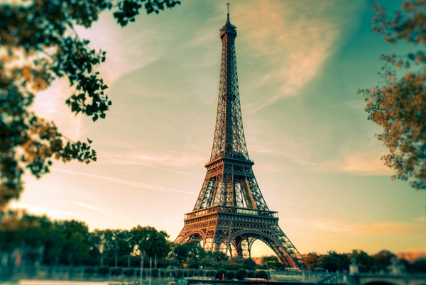

You can add slides to your slideshow if you wish to include more information about your trip!!

