Olympian Gods & Goddesses: Trading Card

- Choose four of the Greek gods & goddesses to research using links on Mr. A's website and the internet.

- Research information and an image for your god/goddess. On the back of your trading card write down at least 7 notes about your god/goddess. On the front of your trading card draw and color a picture of your god/goddess and include their name.

- Your notes should include the following:
- Information about the role of your god/goddess.
(eg. Poseidon was the Lord of the Sea)
- Several of their unique characteristics.
*Poseidon had two brothers: Zeus and Hades.
*He had blue eyes and green hair.
*He could magically make and island appear.
*Ancient Greeks who lived along the coastline were
terrified of him.
- The name of at least one myth about your god/goddess.
(eg. Perseus, Andromeda, and the sea god, Poseidon)
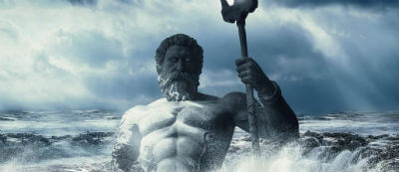
- Any other interesting information.

